TASK 1:

#define _CRT_SECURE_NO_WARNINGS
#include<iostream>
#include<fstream>
#include<cstring>
using namespace std;

class Account
{
private:
char name[50], accNo[20], bank[50], branch[20], city[30];
double balance;
enum Type { CURRENT, SAVING };
Type accType;
static unsigned int count;

public:
Account()
{
name[0] = '\0';
accNo[0] = '\0';
bank[0] = '\0';
branch[0] = '\0';
city[0] = '\0';
balance = 0;
accType = SAVING;
count++;
}

Account(char n[], char a[], int t, double b, char bk[], char br[], char c[])
{
strcpy(name, n);
strcpy(accNo, a);
strcpy(bank, bk);
strcpy(branch, br);
strcpy(city, c);
balance = b;
accType = (t == 0) ? CURRENT : SAVING;
count++;
}

static unsigned int getCount()
{
return count;
}

void deposit(double amt)
{
balance += amt;
}

void withdraw(double amt)
{
if (balance >= amt)
balance -= amt;
else
cout << "Insufficient balance" << endl;
}

void display()
{
cout << "Name = " << name << ", Bank = " << bank << ", City = " << city << ", Balance = " << balance << endl;
}

char* getAccNo()
{
return accNo;
}

void save(ofstream& out)
{
out << name << " " << accNo << " " << bank << " " << branch << " " << city << " " << balance << " " << (int)accType << endl;
}

void load(ifstream& in)
{
int t;
in >> name >> accNo >> bank >> branch >> city >> balance >> t;
accType = (Type)t;
}
};

unsigned int Account::count = 0;

int main()
{
Account* arr[100];
int size = 0;

ifstream fin("accounts.txt");
if (fin)
{
while (true)
{
arr[size] = new Account;
arr[size]->load(fin);
if (fin)
size++;
else
{
delete arr[size];
break;
}
}
fin.close();
}

int choice;
do
{
cout << "1.Create 2.Display All 3.Delete 4.Deposit 5.Withdraw 6.Exit" << endl;
cout << "Enter choice: ";
cin >> choice;

if (choice == 1)
{
char n[50], a[20], bk[50], br[20], c[30];
double b;
int t;

cout << "Enter name: "; cin >> n;
cout << "Enter acc no: "; cin >> a;
cout << "Type (0 Current,1 Saving): "; cin >> t;
cout << "Enter balance: "; cin >> b;
cout << "Enter bank: "; cin >> bk;
cout << "Enter branch: "; cin >> br;
cout << "Enter city: "; cin >> c;

arr[size] = new Account(n, a, t, b, bk, br, c);
size++;
}

else if (choice == 2)
{
for (int i = 0; i < size; i++)
arr[i]->display();
}

else if (choice == 3)
{
char a[20];
cout << "Enter acc no to delete: ";
cin >> a;

for (int i = 0; i < size; i++)
{
if (strcmp(arr[i]->getAccNo(), a) == 0)
{
delete arr[i];
for (int j = i; j < size - 1; j++)
arr[j] = arr[j + 1];
size--;
break;
}
}
}

else if (choice == 4)
{
char a[20];
double amt;
cout << "Enter acc no: "; cin >> a;
cout << "Enter amount: "; cin >> amt;

for (int i = 0; i < size; i++)
if (strcmp(arr[i]->getAccNo(), a) == 0)
arr[i]->deposit(amt);
}

else if (choice == 5)
{
char a[20];
double amt;
cout << "Enter acc no: "; cin >> a;
cout << "Enter amount: "; cin >> amt;

for (int i = 0; i < size; i++)
if (strcmp(arr[i]->getAccNo(), a) == 0)
arr[i]->withdraw(amt);
}

} while (choice != 6);

ofstream fout("accounts.txt");
for (int i = 0; i < size; i++)
arr[i]->save(fout);
fout.close();

for (int i = 0; i < size; i++)
delete arr[i];

return 0;
}

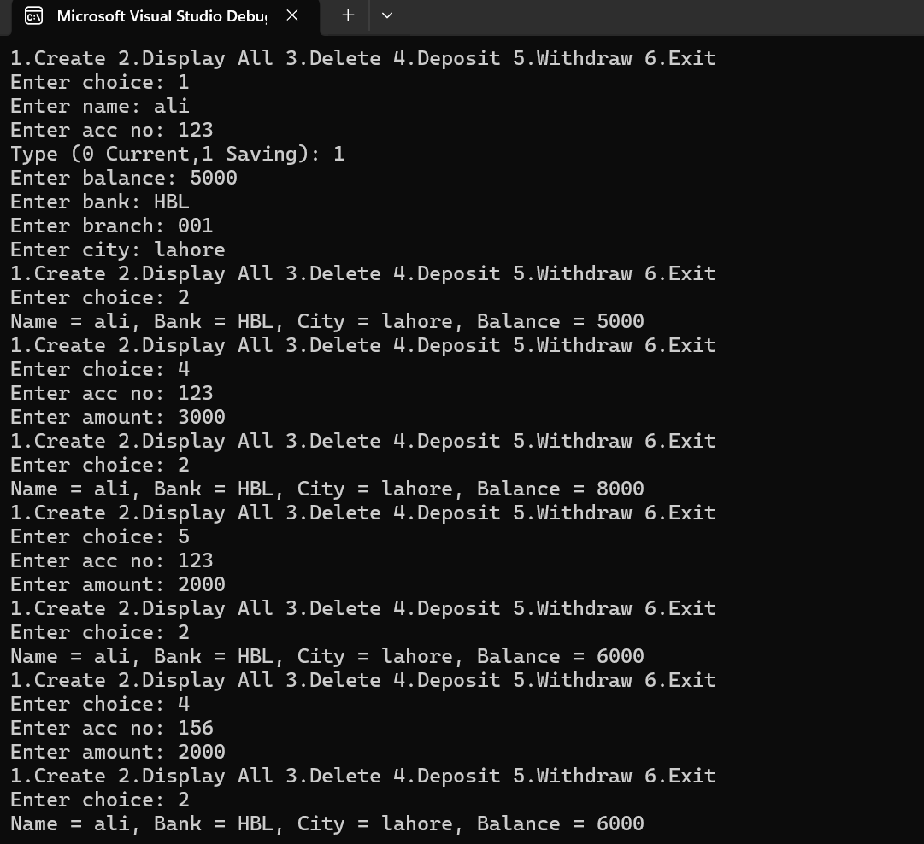

TASK 2:

#include<iostream>
using namespace std;

class HotDogStand
{
private:
int id;
int sold;
static int total;

public:
HotDogStand(int i, int s)
{
id = i;
sold = s;
total += s;
}

void justSold()
{
sold++;
total++;
}

int getSold()
{
return sold;
}

static int getTotal()
{
return total;
}
};

int HotDogStand::total = 0;

int main()
{
HotDogStand s1(1, 5);
HotDogStand s2(2, 3);
HotDogStand s3(3, 7);

s1.justSold();
s2.justSold();
s2.justSold();
s3.justSold();

cout << "Stand 1 sold = " << s1.getSold() << endl;
cout << "Stand 2 sold = " << s2.getSold() << endl;
cout << "Stand 3 sold = " << s3.getSold() << endl;

cout << "Total hot dogs sold = " << HotDogStand::getTotal() << endl;

return 0;
}
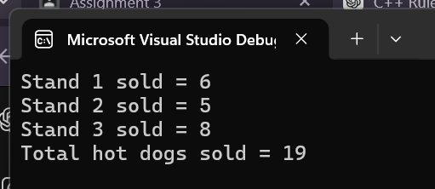

TASK 3:

#include <iostream>
#include <string>
using namespace std;

struct Student {
string name;
string cnic;
string gender;
float cgpa;
};

class Section {
private:
Student students[40];
string sectionName;
string classTeacher;
int studentCount;

public:
Section() {
sectionName = "Not Set";
classTeacher = "Not Set";
studentCount = 0;
}

void editSection() {
cin.ignore(); // buffer clear
cout << "Enter Section Name: ";
getline(cin, sectionName);
cout << "Enter Class Teacher Name: ";
getline(cin, classTeacher);
}

void addStudent() {
if (studentCount >= 40) {
cout << "Section full, cannot add more students." << endl;
return;
}
cin.ignore();
cout << "Enter Student Name: ";
getline(cin, students[studentCount].name);
cout << "Enter Student CNIC: ";
getline(cin, students[studentCount].cnic);
cout << "Enter Gender: ";
getline(cin, students[studentCount].gender);
cout << "Enter CGPA: ";
cin >> students[studentCount].cgpa;
studentCount++;
}

void updateStudent() {
string searchCNIC;
cin.ignore();
cout << "Enter CNIC of student to update: ";
getline(cin, searchCNIC);
for (int i = 0; i < studentCount; i++) {
if (students[i].cnic == searchCNIC) {
cout << "Updating Student: " << students[i].name << endl;
cout << "Enter New Name: ";
getline(cin, students[i].name);
cout << "Enter New Gender: ";
getline(cin, students[i].gender);
cout << "Enter New CGPA: ";
cin >> students[i].cgpa;
return;
}
}
cout << "Student not found!" << endl;
}

void printList() {
cout << "\nSection: " << sectionName << ", Teacher: " << classTeacher << endl;
cout << "Student List:\n";
for (int i = 0; i < studentCount; i++) {
cout << i + 1 << ". Name: " << students[i].name
<< ", CNIC: " << students[i].cnic
<< ", Gender: " << students[i].gender
<< ", CGPA: " << students[i].cgpa << endl;
}
}
};

int main() {
Section sec1;
int choice;

do {
cout << "\n1. Edit Section\n2. Add Student\n3. Update Student\n4. Print List\n5. Exit\nEnter choice: ";
cin >> choice;

switch (choice) {
case 1: sec1.editSection(); break;
case 2: sec1.addStudent(); break;
case 3: sec1.updateStudent(); break;
case 4: sec1.printList(); break;
case 5: cout << "Exiting program."; break;
default: cout << "Invalid choice!"; break;
}
} while (choice != 5);

return 0;
}

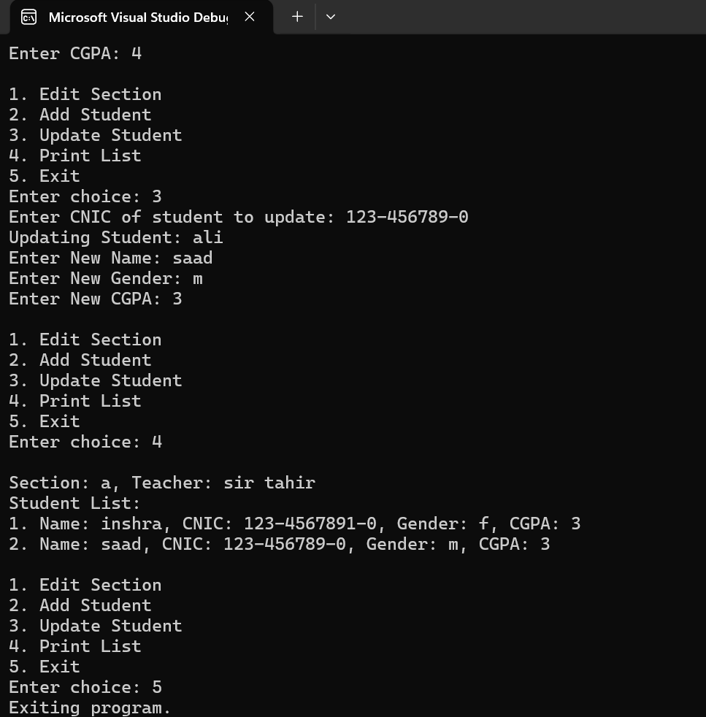

TASK 4:

#include <iostream>
using namespace std;

class Toll
{
private:
unsigned int cars;
double cash;

public:

Toll() : cars(0), cash(0) {}

void payCar()
{
cars++;
cash += 50;
}

void nopayCar()
{
cars++;
}

void show() const {
cout << "Total cars: " << cars << ", Total cash: Rs " << cash << endl;
}
};

int main()
{
Toll t;
int ch;

do
{
cout << "\n1=Paying Car, 2=Non-Paying Car, 3=Show Totals, 4=Exit\nChoice: ";
cin >> ch;

switch (ch)
{
case 1: t.payCar(); break;
case 2: t.nopayCar(); break;
case 3: t.show(); break;
case 4: cout << "Exiting."; break;
default: cout << "Invalid choice.\n";
}
} while (ch != 4);

return 0;
}

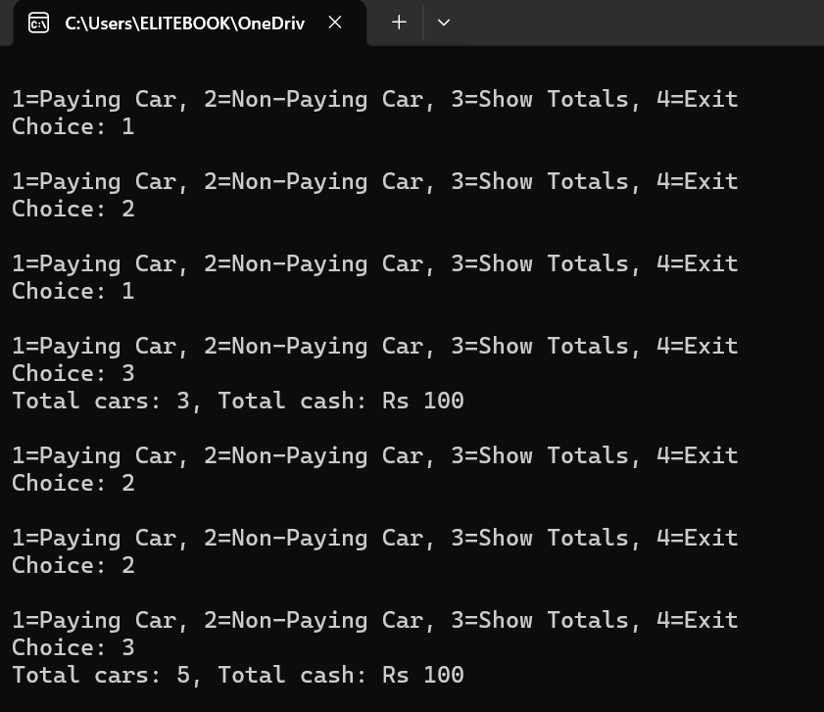

TASK 5:

#include <iostream>
#include <iomanip>
using namespace std;

class Time
{
private:
int h, m, s;

public:

Time() : h(0), m(0), s(0) {}
Time(int hh, int mm, int ss) : h(hh), m(mm), s(ss) {}
void show() const
{
cout << setfill('0') << setw(2) << h << ":"
<< setw(2) << m << ":"
<< setw(2) << s << endl;
}

void add(const Time& t1, const Time& t2) {
s = t1.s + t2.s;
m = t1.m + t2.m + s / 60;
s %= 60;
h = t1.h + t2.h + m / 60;
m %= 60;
h %= 24;
}
};

int main()
{

Time t1(2, 45, 50);
Time t2(3, 20, 15);
Time t3;
t3.add(t1, t2);
cout << "Time 1: "; t1.show();
cout << "Time 2: "; t2.show();
cout << "Sum of Time 1 and Time 2: "; t3.show();

return 0;
}

